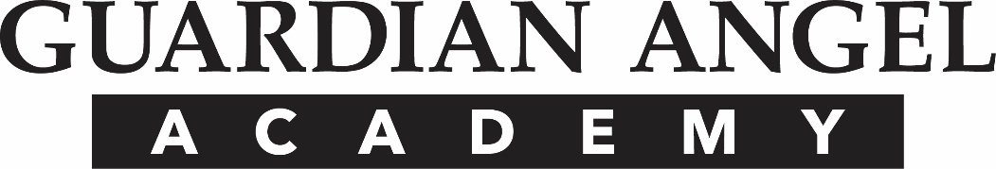
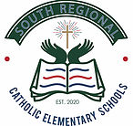

915 Alice Street Pittsburgh, PA 15220
www.guardianangelacademy.org
412-922-4765 Office
412-922-4647 Fax

CATHOLIC SCHOOL PARENTS MEMORANDUM OF UNDERSTANDING

CATHOLIC SCHOOL PARENTS MEMORANDUM OF UNDERSTANDING

As a parent/guardian of a student in a Catholic school, I understand, affirm, and support the following:

- The primary purpose of a Catholic school education is to form students in the values of Jesus Christ and the teaching of the Catholic Church.
- Catholic schools are distinctive religious education institutions operated as programs of the Catholic Church; they are not private schools but are administered and supported by the sponsoring parish(es), the diocese, or religious community.
- Attending a Catholic school is a privilege, not a right.
- While academic excellence and involvement in extracurricular activity (i.e., sports, clubs, etc.) are important, fidelity to the Catholic identity of the school is the fundamental priority.
- The school and its administration have the responsibility to ensure that Catholic values and moral integrity permeate every facet of the school’s life and activity.
- In all questions involving faith, morals, faith teaching, and Church law, the final determination rests with the diocesan bishop.

As a parent/guardian desiring to enroll my child in a Catholic school, I accept this memorandum of understanding. I pledge support for the Catholic identity and mission of this school and by enrolling my child I commit myself to uphold all the principles and policies that govern a Catholic school.

Father: Mother: Guardian:
_________________________ _________________________ __________________________
Printed Printed Printed
__________________________ __________________________ __________________________
Signature Signature Signature
_______________________________________ ______________________________________
Student’s Name (Please Print) School
_______________________________________ ______________________________________

Date:___________________________________

